How to Open a Bank Account
Opening a bank account isn't as simple as walking up to a teller and handing over your money. Creating a new account requires preparation and thought. For example, you'll need to decide which type of account you want and how you want to use it. Luckily, this process isn't difficult once you know a few banking basics.

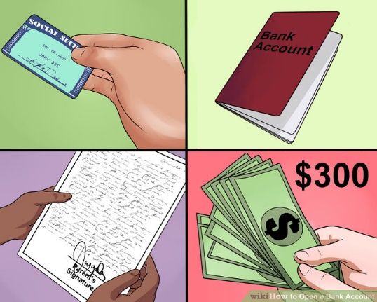
- Make sure you're eligible to open an account. Before you head to the bank, it's wise to check whether you meet all the criteria for opening an account. As a general rule, most banks will require the following:
- Proof that you are who you say you are. Bring a government-issued photo ID with you (a driver’s license or a passport are best).
- Proof of address: A phone bill, driver’s license, or any other official document with your name and address will usually do.
- Proof that you are a “registered” citizen: The bank will ask for your social security number.
- You'll need to have at least the minimum amount of money for opening account. This can vary based on the bank and account you choose. For example, a basic Bank of America savings account requires a minimum deposit of $300.^{[2]}

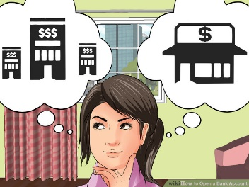
- Choose the bank that's best for you. Not all banks are the same, even when it comes to basic personal accounts. It can be very wise to contact the banks in your local area to discuss what exactly you'd get if you opened a basic account. While all banks are different, they can generally be lumped into two general categories: large chain banks and smaller local ones. See below:^{[3]}
- Large chain banks: Large banks usually have branches in most towns and cities across the country, which means you'll be able to get basically the same service no matter where you go. This wide coverage can help you avoid fees you'll have to pay for using other banks' services (like ATM fees, etc.) Large banks also usually have the resources to offer services like 24-hour help lines for their customers. In addition, these banks tend to have a stable, trusted reputation — they are unlikely to fail or present you with "surprise" difficulties.
- Smaller local banks: Small banks offer a more personal, human experience. They tend to be friendlier than big banks in several ways — not only will they be willing to offer more personal, one-on-one attention, but they'll often be willing to "work with you" when something goes wrong (like you overdraft from your account). Smaller banks also usually charge smaller fees for using their services. On the other hand, smaller banks fail more frequently than large banks (this is still very rare, though).^{[4]}

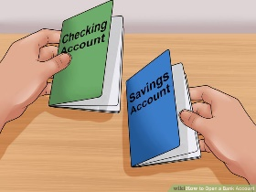
- Pick the type of account you want. Most of the time, when someone opens his or her first bank account, it is a regular checking or savings account (or both). Both of these types of accounts allow you to safely store your money with the bank and withdraw it when you need it. However, each type of account is best for different tasks. See below:
- Checking: A checking account is what most people use for day-to-day purchases. With a checking account, you'll get a debit card that you can use to pay for things with the money in your account. Money in a checking account doesn't change over time — if you want more money, you have to put it in yourself.
- Savings: As its name suggests, a savings account is best for saving money long-term. Money in a savings account slowly gains interest — in other words, the bank will pay you a small amount for storing your money with it. The more money you have in the account and the longer you save it, the more interest you get. You can still withdraw money from a savings account at banks and ATM, but you can't generally use it for debit card payments.
- If you have enough money to meet the minimum deposit for both, having both a checking and a savings account is usually best. You can use the checking account for your daily expenses and put extra money in your savings to earn interest.

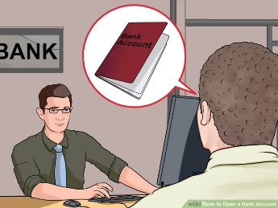
- Visit your bank and ask to open an account. Opening an account in person is usually the best option for first-time account holders. One big advantage of opening an account in person is that you can ask the teller all of your questions and get immediate answers (as opposed to the waiting you'll have to do online or on the phone). Also, because you can sign the forms and receive your confirmation documents on the spot, the process of opening an account is also usually speedier in person.

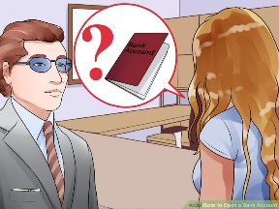
- Ask important questions before you finalize your account. Now is an excellent time to ask for clarification on any issues regarding your account that you don't understand. Below are a few suggestions for questions you may want to ask, but don't be afraid to ask any others that occur to you.
- Is there a monthly fee for maintaining this account? If so, what is it?
- Is there a minimum balance that I must keep within this account? If so, what is it? What sorts of fees apply if I go under that limit?
- What is the interest rate of my savings account? How often does interest generate?
- Is there a limit to the amount of transactions (deposits/withdrawals, check writing, ATM uses) I have per month?
- Where can I withdraw cash without paying any fees? What is the fee for using an ATM that doesn't belong to this bank?
- Is the account I'm applying for insured by a Deposit Guarantee Scheme (DGS)?[5]

